**Ultrasonic Distance Measurement using Arduino**

**Introduction:**

This project demonstrates how to measure distance using an **ultrasonic sensor** and **Arduino Uno**. It's a simple yet effective way to understand how electronic sensors interact with microcontrollers to produce useful real-world data.

**Project Description:**

In this circuit, an **HC-SR04 ultrasonic sensor** is used to detect the distance of objects from the sensor by sending out ultrasonic waves and measuring the time it takes for the echo to return. The Arduino Uno processes the data and outputs the distance on a serial monitor or an LCD display. This project is commonly used in obstacle-avoiding robots, parking sensors, and automation systems.

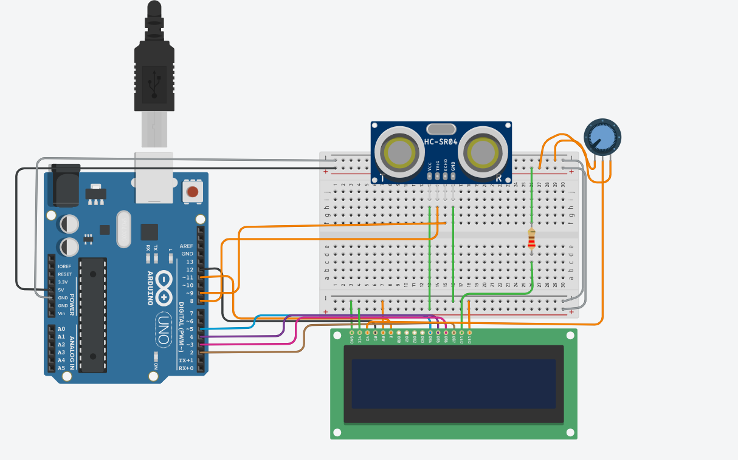

**Connection Explanation:**

**🔷 1. Arduino to HC-SR04 Ultrasonic Sensor:**

| **Sensor Pin** | **Connected To** | **Purpose** |
| --- | --- | --- |
| VCC | 5V on Arduino | Power supply for the sensor |
| GND | GND on Arduino | Common ground |
| Trig | Digital Pin **9** | Sends trigger pulse |
| Echo | Digital Pin **10** | Receives echo signal |

**🔷 2. Arduino to 16x2 LCD Display (with Potentiometer):**

| **LCD Pin** | **Connected To** | **Purpose** |
| --- | --- | --- |
| VSS | GND | Ground |
| VDD | 5V | Power supply |
| V0 | Middle pin of potentiometer | Controls display contrast |
| RS | Digital Pin **7** | Register select for data/command mode |
| RW | GND | Set to write mode |
| E (Enable) | Digital Pin **6** | Enables data transfer |
| D4 | Digital Pin **5** | Data pin 4 |
| D5 | Digital Pin **4** | Data pin 5 |
| D6 | Digital Pin **3** | Data pin 6 |
| D7 | Digital Pin **2** | Data pin 7 |
| A (LED+) | 5V | Backlight power |
| K (LED-) | GND | Backlight ground |

**3. Potentiometer (Contrast Control):**

* **One outer pin** → GND
* **Other outer pin** → 5V
* **Middle pin** → V0 (pin 3 of LCD)  
  This controls the **contrast** of the LCD display.

Code:

#include <LiquidCrystal.h>

LiquidCrystal lcd(12, 11, 5, 4, 3, 2);

const int trigPin = 9;

const int echoPin = 8;

void setup() {

lcd.begin(16, 2);

lcd.print("Ultrasonic Init");

pinMode(trigPin, OUTPUT);

pinMode(echoPin, INPUT);

delay(2000);

lcd.clear();

lcd.print("Measuring...");

}

void loop() {

digitalWrite(trigPin, LOW);

delayMicroseconds(2);

digitalWrite(trigPin, HIGH);

delayMicroseconds(10);

digitalWrite(trigPin, LOW);

long duration = pulseIn(echoPin, HIGH);

int distance = duration * 0.034 / 2;

lcd.clear();

lcd.print("Distance: ");

lcd.print(distance);

lcd.print(" cm");

  delay(500);

}